Professional Headline

Job Title or a more general desc of the role you want to play. Make it fun

A brief bio

Keep it professional and brief. Professionally taken photo

Resume

Professional summary

What you do and how you can help them

Samples of your work

Results

Quanitfiable results from the past.

Add links to articles about you or quote you to prof journals or readings to your professional

Testimonials!!

Be sure to put a link to your website in your e-mail signature, on your resume and cover letter, and on social networking profiles such as LinkedIn.

1. About Me

>Hello world!

>My name is Srishti.

>I am an aspiring engineer and data scientist with a background in aerospace engineering.

>I enjoy using machine learning, parallel computing, physics, math, cool programming, computer science memes and all things data science.

>I currently work at the National Research Council Canada’s Institute for Aerospace Research in Ottawa.

> I will graduate from Engineering Science with a major in Aerospace Engineering and minors in Robotics and Business from the University of Toronto.

I specialize in developing high-quality and novel programs and applications in various languages to analyze data.

1. Where I’ve worked

NRC

Ramachandran’s Lab

SPAN

VEEP

Talent is my craft.  
I love **building powerful teams** and **tuning them to perform at their best.**

I've designed and run systems that have hired 5,600+ people for at over 100 organizations, and done extensive research into the key elements of effective team building & management.

KEY COMPETENCIES

**talent strategy & brand - executive search - hiring process design - recruiting - team performance**

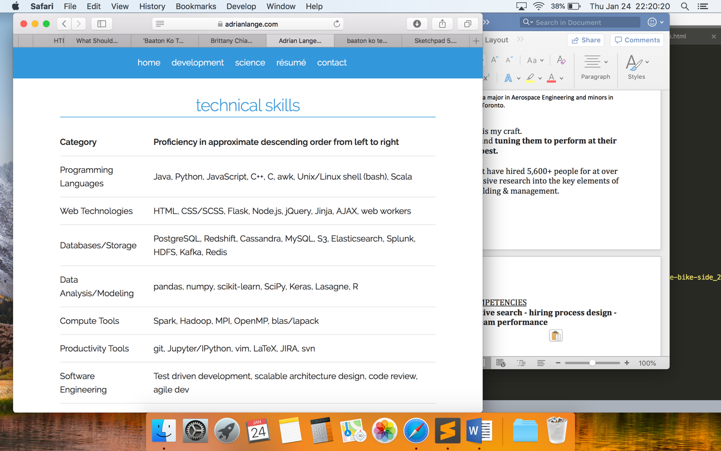

03. Projects and additional experience

Building a Fully convolutional neural network based on this paper.

Constructing a novel architecture to classify data for a system health monitoring application

Developing code to run networks on multi GPUs

Working with Arduinos to power a RC car for my cats

Building a fully autonomous bottle sorter robot

I have worked on multiple team design projects such as building an integrated skate drying shelf. Iterative thinking and rapid prototyping are my strengths.

Personal Website

Chrome Extenssion to block adds using machine learning technqiues

**Spotify’s Top Tracks of 2017**

R Project for my Data Science class at Northeastern to analyze the top Spotify tracks of 2017 and their audio features. <https://github.com/bchiang7/spotify-top-tracks-2017>

Semantic Similarity based Program: an intelligent system that can learn to answer questions like choosing a synonym of a word out of a list of words. The training set of this exercise is a passage from the novels Swann’s Way by Marcel Proust, and War and Peace by Leo Tolstoy and the cosine similarity measure and the negative distance in Euclidean space between the vectors were used as a similarity metric. This is the project: <https://www.cs.toronto.edu/~guerzhoy/180/proj/P3/synonyms.pdf> This project sparked my interest in programming and machine learning.

04. Honours and awards

05. Publications

IJPRAI

ASTESJ

ICPRAI

HUMS

CASI

RAJESH PAPER

06. Hobbies and Activities

When I’m not working, there are a few places where you can find me.

* Leading school clubs (links to each)
  + NSight Mentorship
  + Galbraith Society
  + UTSDC
* Promoting Women in STEM (contibutions at NRC, uoft, outside school)
* Bhartanatyam:
* Cooking:
* Playing the guitar:
* Getting involved in some programming side projects
* Playing with my cats:

**What's Next?**

#### Get In Touch

Although I'm not currently looking for any freelance opportunities, my inbox is always open. Whether for a potential project or just to say hi, I'll try my best to answer your email!

Designed and built by Srishti Sehgal @ 2019

